Sprint 1: Checking the City at the moment with the cars
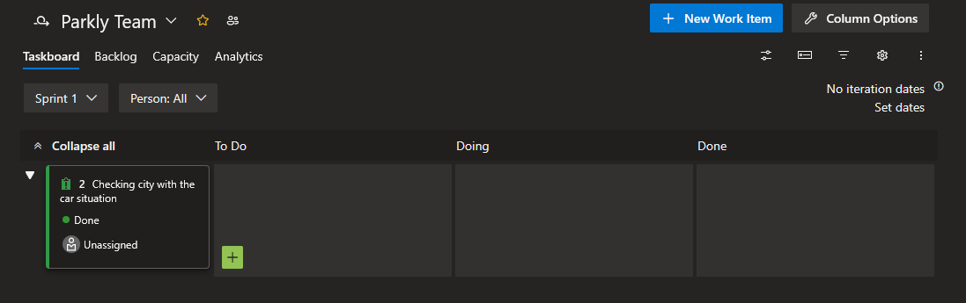
Sprint 2: Planning the App
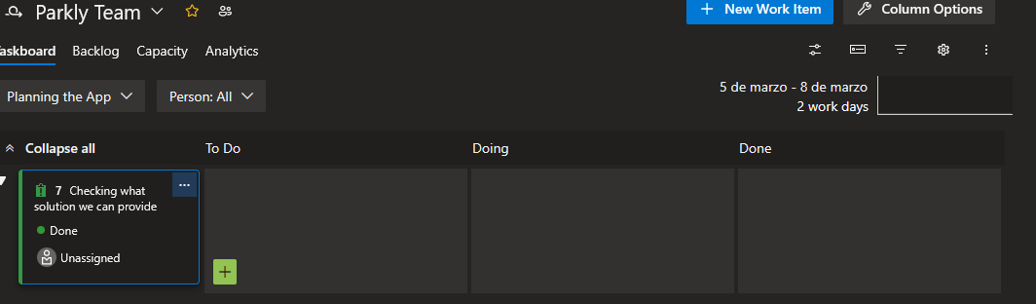
Sprint 3: Making the Prototypes
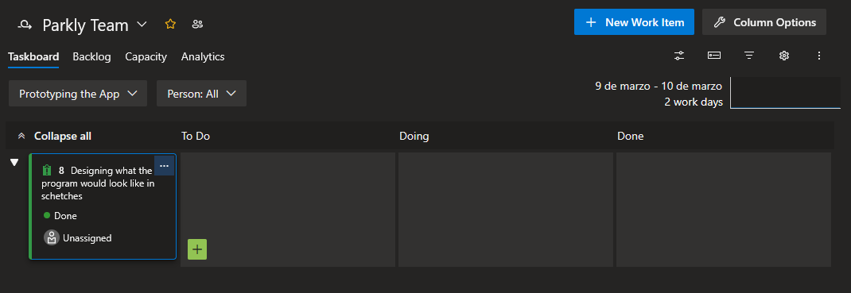
Sprint 4: Making Front and Backend
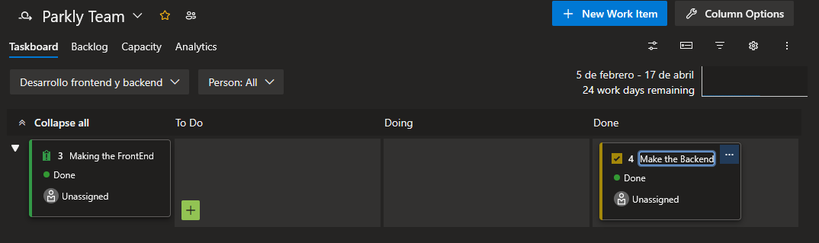
Sprint 5: Checking Program for any defects along the way
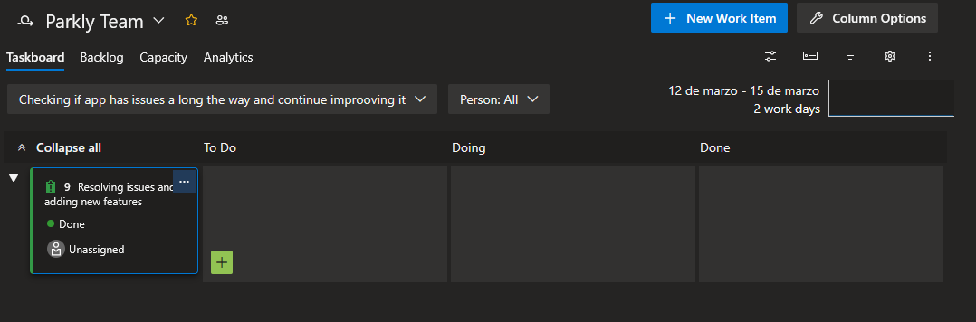
Sprint 6: Seeing if the program passes the quality standards and test
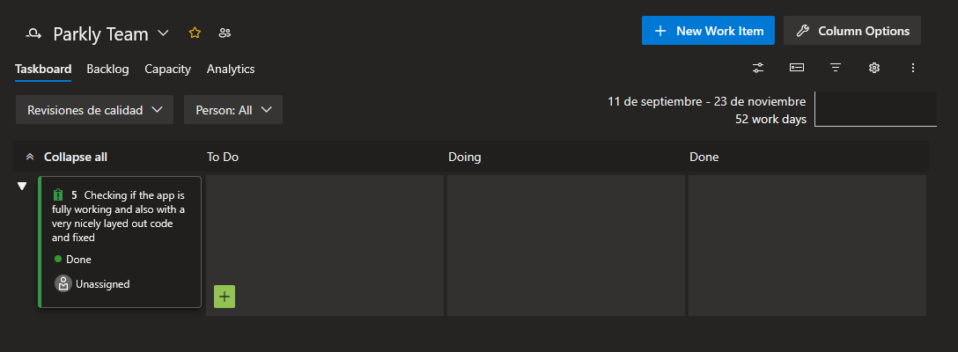
Sprint 7: Documenting the whole process and requirements
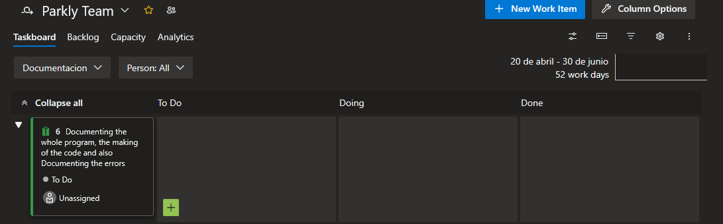
Sprint 8: Upload the App online
